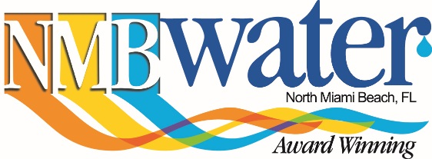

Construction Notice

OVERVIEW
NMB Water is scheduled to begin a water valve replacement project in the Town of Golden
Beach on March 31, 2017. The project will take place on Center Island on The Strand, from the cul-de-sac at Strand Park to Center Island Drive. The installation will be made by a NMB Water approved contractor, Envirowaste Services Group, Inc. The project will take place on weekdays between March 31, 2017 and April, 14, 2017. Once the work is complete, the street and swales affected by the project will be repaired to pre-construction conditions.

LOCATION: Between Strand Park and Center Island Drive.

WATER SERVICE: The project will NOT affect water quality or service.

SCOPE OF WORK: Replacement of water main valve.

PROJECT DATES: March 31, 2017 through April, 14, 2017.

TRAFFIC: Expect a temporary lane closure on The Strand cul-de-sac, west of Center Island Drive and Strand Park.

NMB Water strives to provide the best water service possible to its customers. We apologize for any inconvenience this may cause and thank you for your patience.
For more information regarding this project, contact:
Para mas información acerca de este proyecto, por favor llame a:
Pou infomasyon sou pwoje-sa-a, tampri rele nimero:

Karim Rossy, NMB Water Chief Engineer (305) 948-2980, ext. 7951
John Pollard, NMB Water Inspections Manager (305) 948-2980, ext. 7951
Mark Perkins, NMB Water Public Information Officer (305) 957-3657
Envirowaste Services Group, Inc., Mike Garcia Operations Manager (305) 796-9357

