
GOLDEN BEACH POLICE DEPARTMENT
2021 ANNUAL REPORT

Mission Statement
To provide courteous and ethical high quality police and public safety services to all by practicing professionalism and community-policing while protecting life and preventing crime.
Vision
To be an internationally recognized example in the delivery of professional, community-policing based law enforcement services that are courteous and ensuring the highest levels of performance and community satisfaction.


Values
We value honesty, ethics, courtesy, respect and community-policing in all aspects with our residents, our fellow Town employees, visitors, and all others with whom we interact; we exist to serve the residents and will demonstrate this in every possible way; we assist every employee in every way to reach their maximum potential; we operate as a team in a friendly, helpful, and informal working environment while maintaining our professionalism as a law enforcement agency.

Chief’s Message
I am very pleased to present the Town of Golden Beach Police Department’s 2021 Annual Report. Even though Covid-19 pandemic became an additional challenge, 2021 was a productive and successful year for the Golden Beach Police Department. Overall, our crime statistics were very flat. Lowering the crime trend can certainly be attributed to the men and women of this department, both sworn and civilian, who have worked tirelessly to make the Town of Golden Beach a safe place to live. Our high visibility details and other proactive approach has enabled us to keep criminals at bay, which has even lowered our “Part II” total arrests making our town one of the safeties municipalities in south Florida.
Introduction
The police department responds to requests for police services, quality of life calls, along with providing service to code enforcement concerns. When needed, the department also assists the police departments of neighboring municipalities through mutual aid agreements. The Town’s Community Policing services include a dedicated Community Policing Officer, in addition to various specialized unit services, along with local programs established for the prevention of crime. These units are involved in conducting preliminary and follow up investigations, conducting traffic enforcement activities and operations, and maintaining internal controls and policies to ensure the delivery of professional services that are fair, efficient and effective.
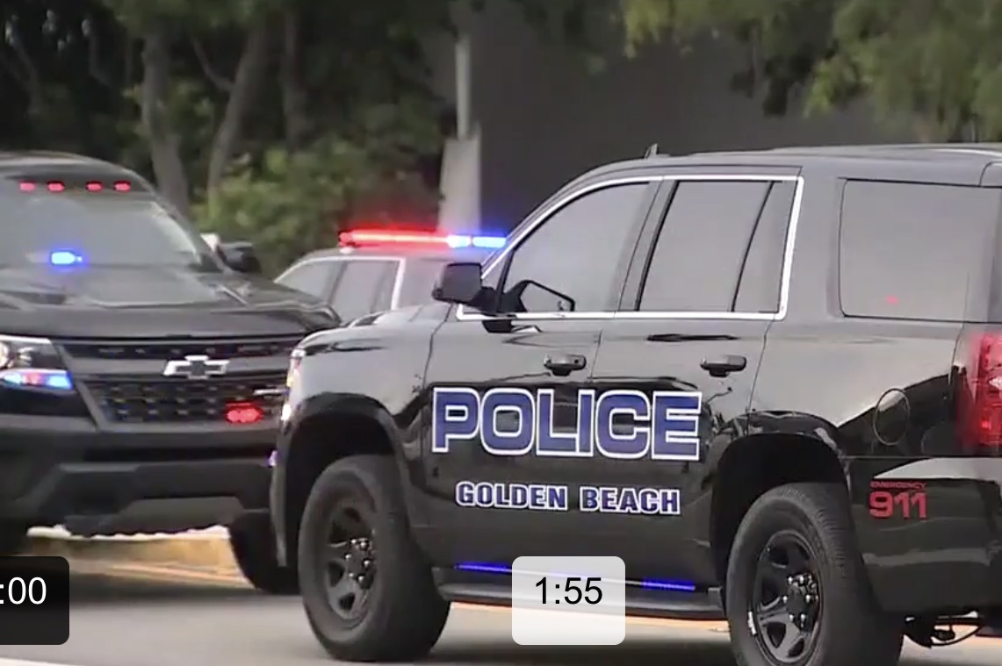

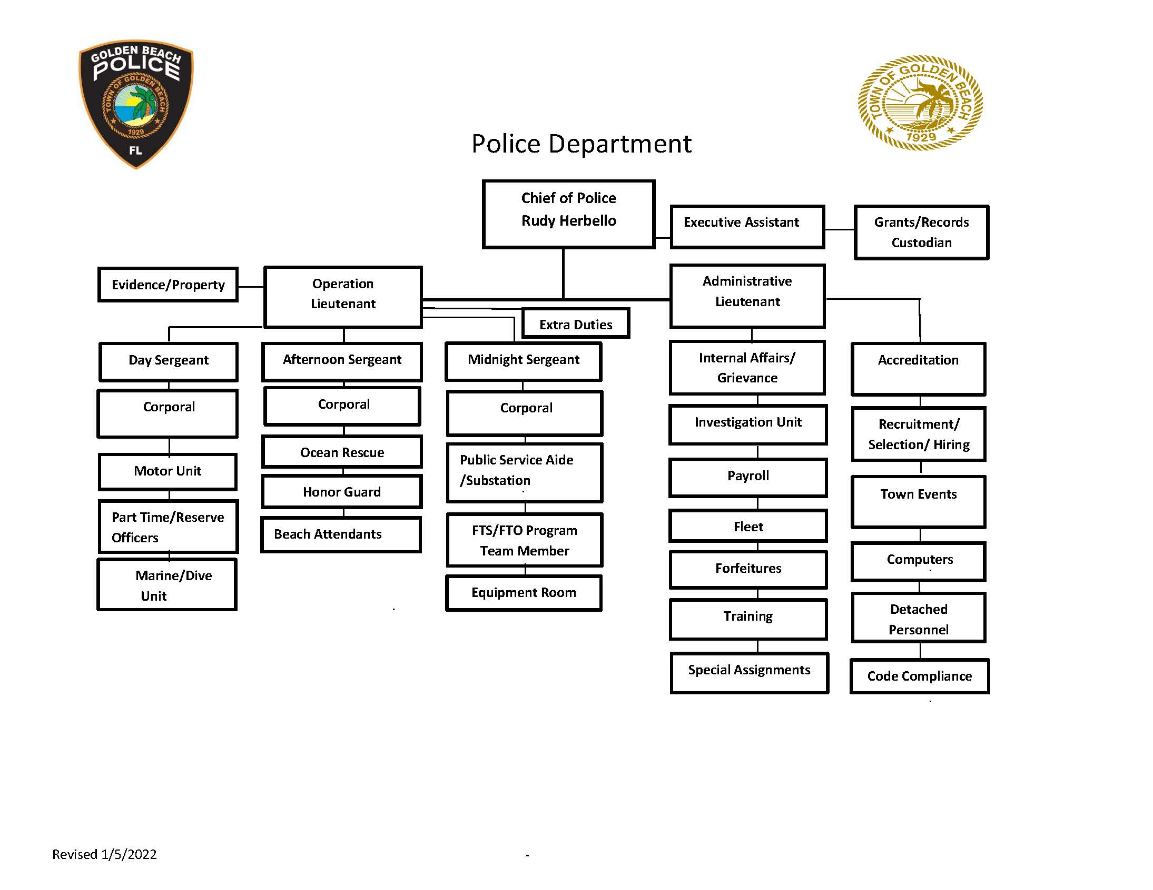
Personnel
- As of January 01, 2022, the Town of Golden Beach employs nineteen (19) full time police officers, eight (8) part-time police officers, three (3) reserve police officers, one (1) Administrative Assistant, and one Accreditation Manager.
- The Town of Golden Beach has paid the tuition at Miami Dade School of Justice for P/T Officer Dylan Camacho to become a Law Enforcement Officer.

Investigations
The Criminal Investigations Section conducts preliminary, follow-up and special investigations. The objective of investigations is to establish an information base of criminal activity which leads to the identification and apprehension of offenders. The Golden Beach Police Department also have a total of three police officers respectively detached to different State or Federal Task Forces such as the Drug Enforcement Administration (D.E.A), the South Florida Money Laundering Task Force and the Internal Revenue Service (I.R.S) Task Force..

Administration
The Administration Section is responsible for overseeing the services unit and ensuring professional compliance. Administrative Files, Internal Affairs Files, Training Files and Personnel Files are housed within the Administrative Section’s office. The Executive Assistant to the Chief is the custodian of all police files and oversees the administrative function of the Chief’s Office.


Training
Training is an important responsibility of any law enforcement department. Effective training prepares members to act decisively and correctly in a broad spectrum of situations, and reduces the department’s exposure to liability. In establishing guidelines for the development, organization, and administration of the department’s training, it is not enough to just provide training as mandated by the Criminal Justice Standards and Training Commission. Training must also encompass the department’s philosophy in administering applicable Florida laws, Federal laws, local ordinances and department policy. Training should, and will, prepare members of this department to interact with the public and with fellow employees, in a fair and equitable manner consistent with the intent and letter of the law.


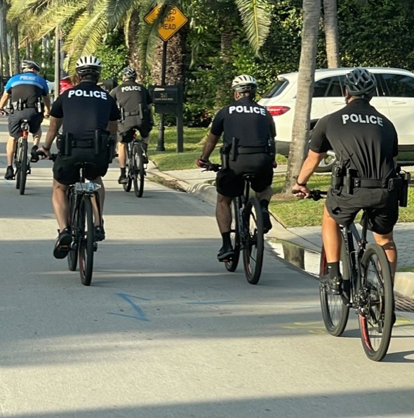

Operations
The Operations section is the largest and most visible component of the police department. It serves as the frontline of crime prevention within the Town. The section is comprised of four assigned patrol units per shift, and also four (4) Motorcycle officers, and the Marine Patrol. Additionally, the Beach attendants, Lifeguards and the Substation/Communications personnel also fall under the Operations Section. Responsible for all police service calls; emergency and non-emergency, protection of life and property, preservation of public peace, prevention and suppression of crime, arrest of violators of the laws, proper enforcement of federal and state laws, county and city ordinances, preventing crimes and apprehending criminals.
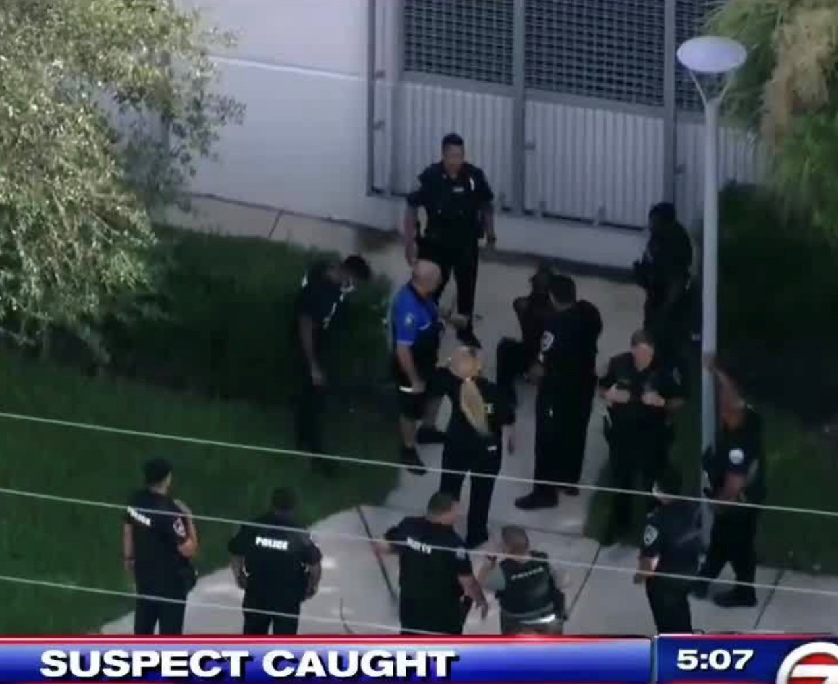

Equipment
- (29) Police Cruisers
- (5) Unmarked vehicles
- (2) Motorcycles
- (1) Command Post Vehicle
- (3) Bicycles
- (2) Segways
- (2) ATV’s for beach patrol
- (1) Marine Vessel
Significant Statistics

Patrol Categories | F/Y 2019-2020 | F/Y 2020-2021
Calls for Service | 1,381 | 1,167
Accident Reports | 30 | 33
Incident Reports | 121 | 91
Resident/Citizen Contacts | 14,356 | 12,759
Watch Orders | 5,070 | 5,546
Field Subject Interviews | 37 | 20
Traffic Citations | 1,164 | 993
Traffic Warnings | 1,345 | 760
Traffic Arrests | 147 | 91
Misdemeanor Arrests | 10 | 9
Felony Arrests | 8 | 3

Marine Patrol | F/Y 2020 | F/Y 2021
Inspections/Vessels | 794 | 320
Citations | 230 | 231
Warnings | 962 | 679

Code Compliance | F/Y 2020 | F/Y 2021
Code Citations | 175 | 238
Code Warnings | 208 | 133



